Folge 9

She'll Be Right

On his way back from Germany, Jörg pays Duncan’s Aussie Aunty Cheryl a flying visit and Duncan teaches him that, though the term “New Zealand” is often understood around the world to be a synonym for “Australia”, “there are some key personality differences you need to be aware of, Jörg”.“She’ll be Right” takes us on a giddying day trip to the South Seas where reverse jandal strap sunburn and “stingers” are balanced nicely by a deep-seated national hunch that everything will be okay.

Aufgabe:

1. Was sind die Freizeitaktivitäten, die man im Bild sehen kann?

2. Was für Essen gibt es?

3. Was wäre –

typisch für Australien

typisch für Neuseeland

typisch für Deutschland

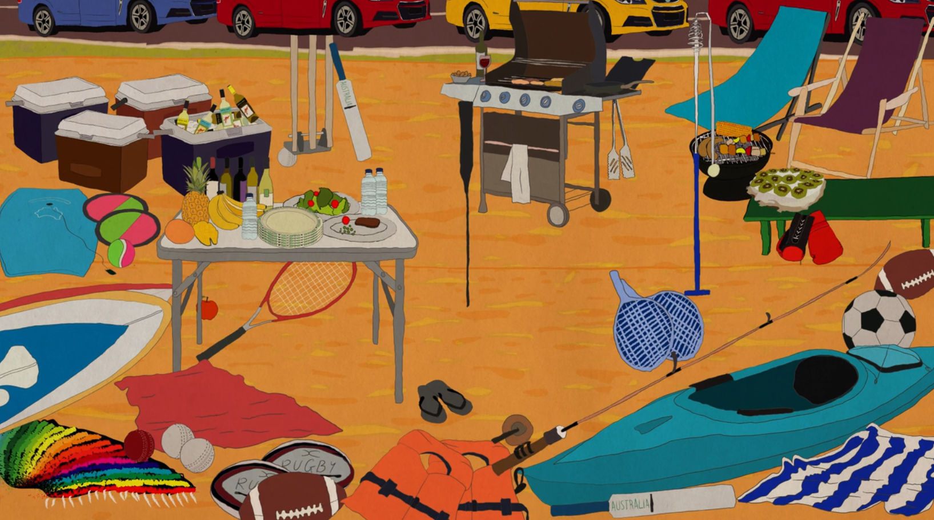

Wortschatz:

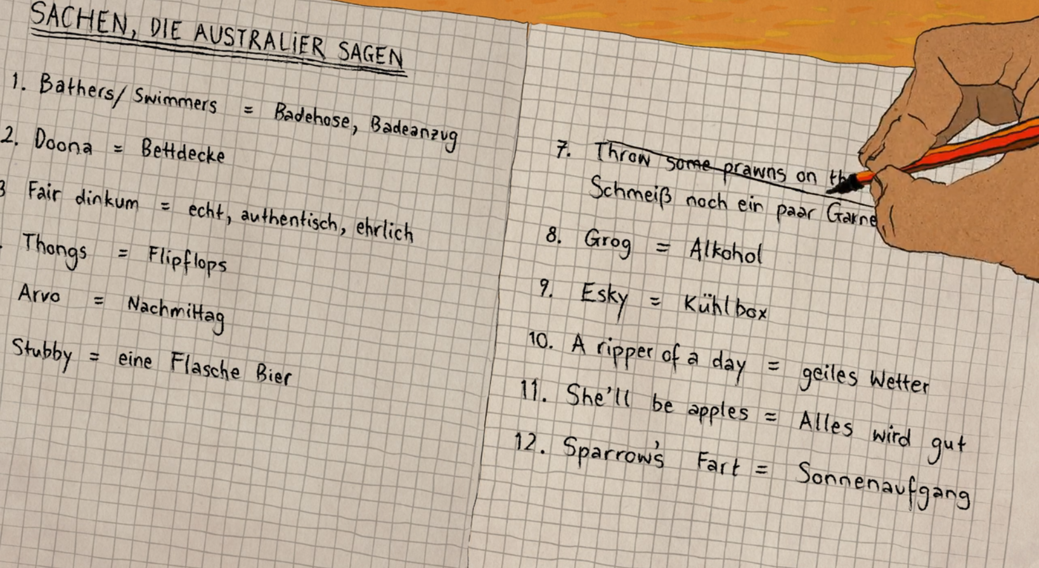

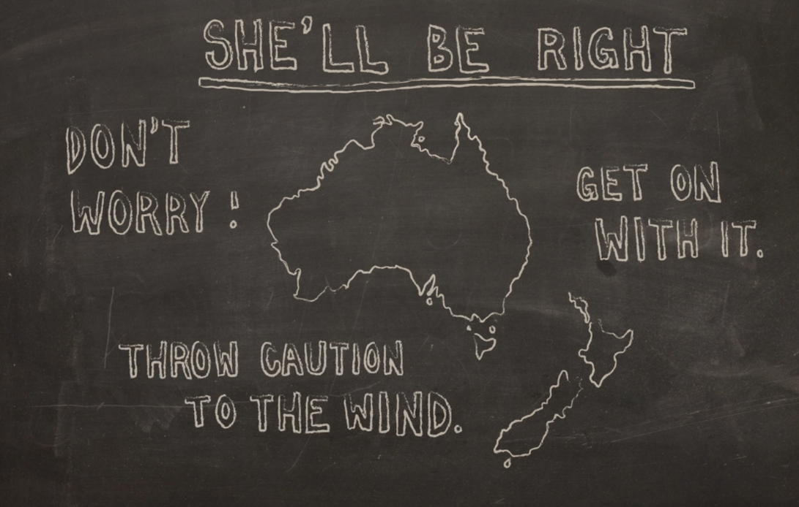

Australische Tiere und Vögel:

