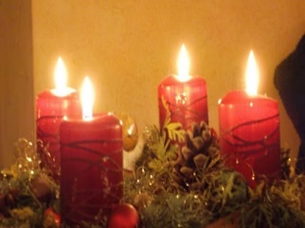  This Photo by Unknown Author is licensed under CC BY-SA | 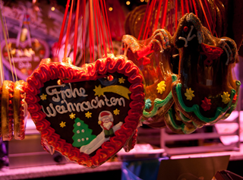 | 

Vocabulary | Use the slideshow  to learn key words about Christmas | Try the Quizlet https://quizlet.com/pt/557029803/weihnachten-flash-cards/ist | Weihnachten - Buchstabensalat worksheet (liveworksheets.com)  Find the words in the word puzzle
Listening | Listen to the “Oh, Tannenbaum“ song. Try to write down as many of the words you understand. Sing along and record yourself if you are brave enough . | Do the following activity on Wordwall.  (less listening, though ) | Listen to an A1 podcast about Weihnachten. Work with a partner. Ask each other questions.
Reading | Find a simple German recipe and make it!  E.g. Der Bratapfel, Vanillekipferl, Stollen, ...  Take a picture! | Do research on „Das Christkind, der Nikolaus, der Weihnachtsmann, der Heiligabend“.  Compare your results. | Read the text about “Engelskirchen”.  What do you understand?
Speaking | How to express your opinion in German and revise numbers from 1-24 in groups. | Learn a Christmas Song and sing in German (Oh, Tannenbaum , “Alle Jahre wieder..”, “Ihr Kinderlein kommet“, „Lasst uns froh und munter sein“). | Was machst du an Weihnachten?  Talk to your partners about it. Exchange ideas.
Writing | Write/ create a Christmas card to a friend or family member | Research how to find Christmas presents using German websites and write a short wishlist / Wunschzettel (Ich wünsche mir ….)  https://www.thalia.de/ | Write guidelines how to make Christmas star.
Culture | Create an Adventskalender using this website. | Find at least three interesting facts about Christmas in Germany.  Share what you find most surprising | Play a Christmas Kahoot.

